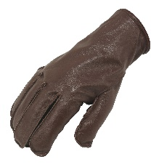
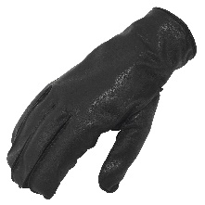
Name: Slash Resistant Leather Patrol Glove
Description: Lined Slash Resistant Leather Glove
Colour: Black or Brown
Item Number: SB01994A

Manufacturer: Southcombe Brothers Ltd
Address: Great Field Lane, Stoke-sub-Hamdon, Somerset, TA14 6QD, UK

This declaration of conformity is issued under the sole responsibility of the manufacturer.
Conformity is shown by compliance with the requirements of the following standards:
BS 7971-7:2003 | Protective clothing and equipment for use in violent situations and in training Slash resistant gloves. Requirements and test methods | Pass

This design is identified as Category II –Intermediate PPE. It is identical to the PPE which is subject of UKCA certificate AB0321/19119-01/E00-00 issued by:
Name: Satra Technology Centre Ltd
Address: Wyndham Way, Telford Way, Kettering, Northamptonshire, NN16 8SD, UK
Approved Body: AB0321

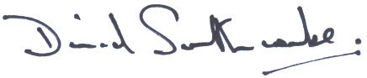
Date: 22/Oct/2021
Place of issue: Stoke-sub-Hamdon, Somerset, UK

David Southcombe
Managing Director
Southcombe Brothers Limited

